**Creating CloudWatch alarms**

Navigate to Cloudwatch alarms console and click on Create alarm

Select the metrics

For creating memory and disk utilization metrics alarms click on CWAgent

Select the ImageId,Instanceid and,Instance type for memory metrics

Select the instance for memory metrics and click on Select metrics

Give the conditions for the alarm

Select the SNS topic to the alarm need to be send

If the SNS topic is not created we can create from the same console

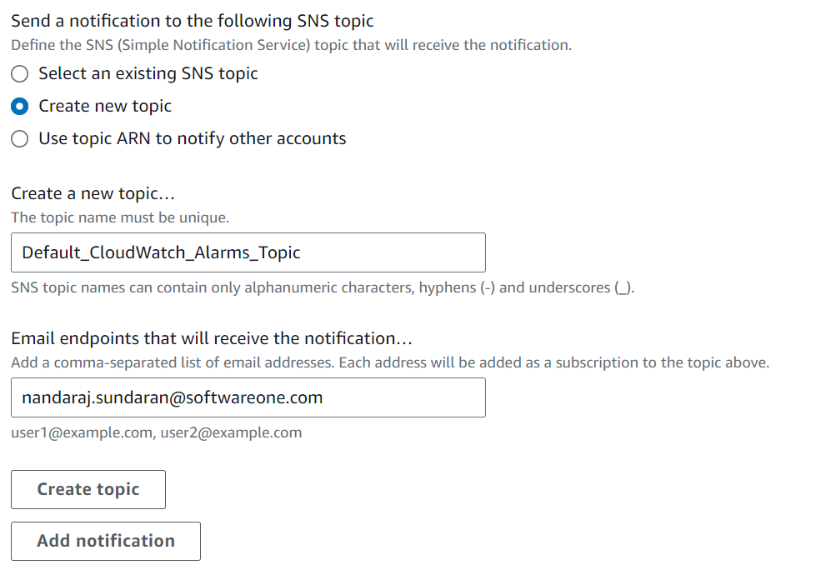

Click Next and add name for alarm and create alarm.

Preview and Create alarm.